双流某重点小学二年级下学期英语期末试题
听力部分
一、听录音，选择正确的图片。
( ) 1. A. B.
( ) 2. A.  B. 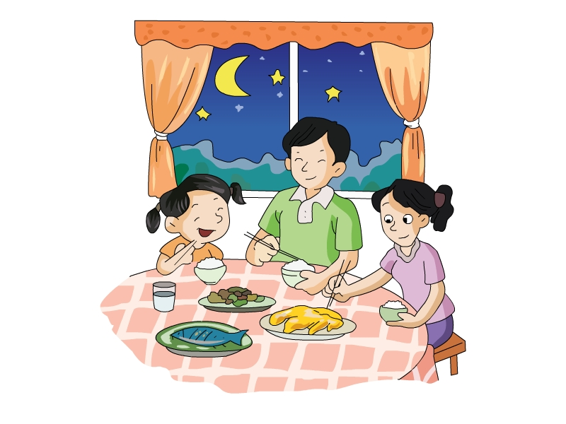
( ) 3. A. B.
( ) 4. A. 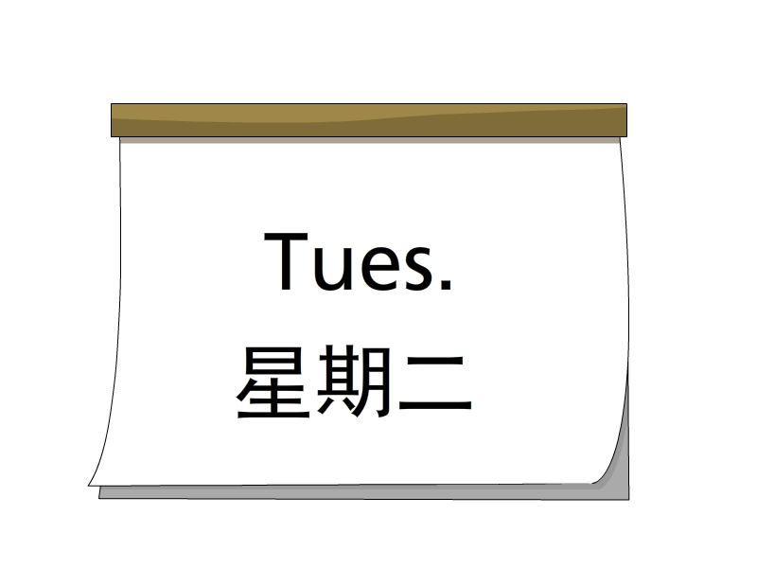 B. 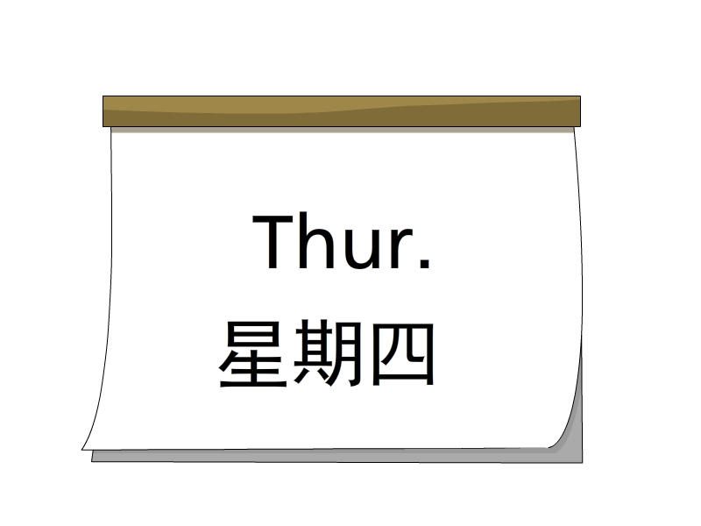
( ) 5. A. 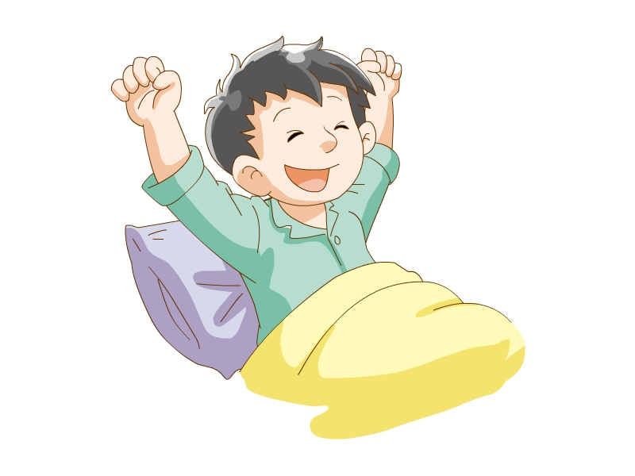 B. 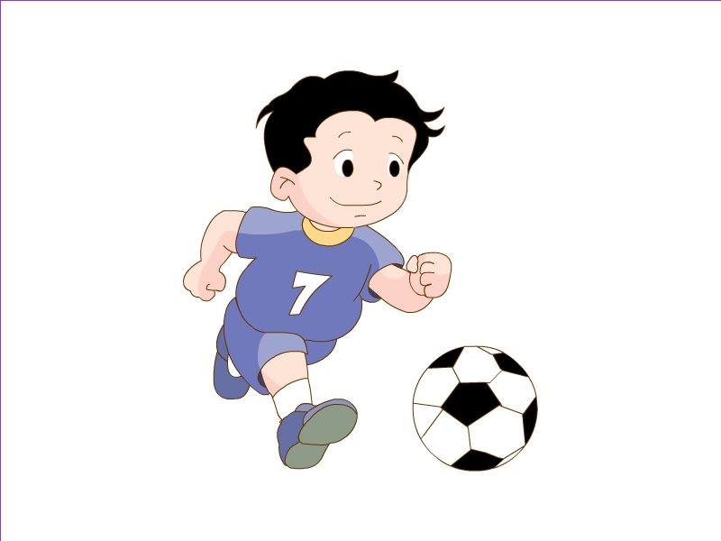
( ) 6. A. 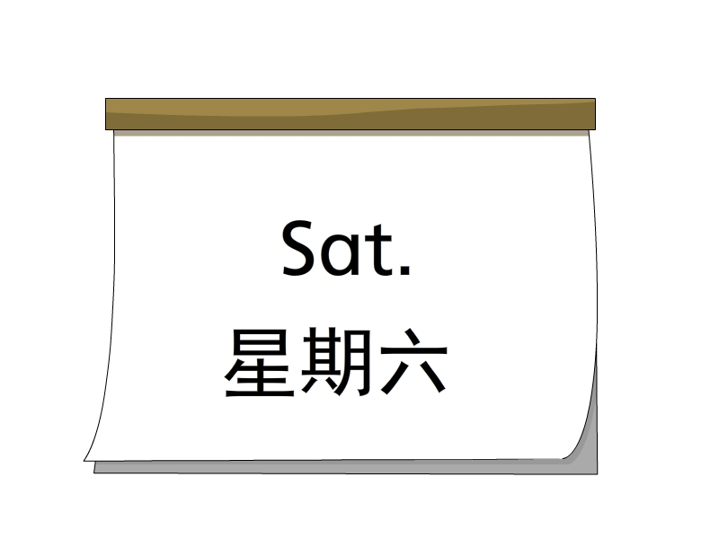 B. 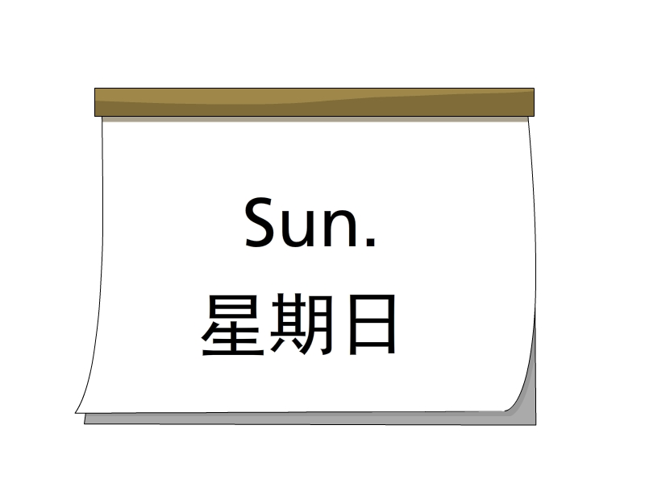
二、听录音，给听到的字母或单词排序。
A B
( ) (1) Ww ( ) (1) thirty
( ) (2) Yy ( ) (2) Monday
( ) (3) Mm ( ) (3) fifty
( ) (4) Xx ( ) (4) Sunday
( ) (5) Ss ( ) (5) today
三、听录音，判断图片正误，用“√”或“×”表示。
( ) 1. 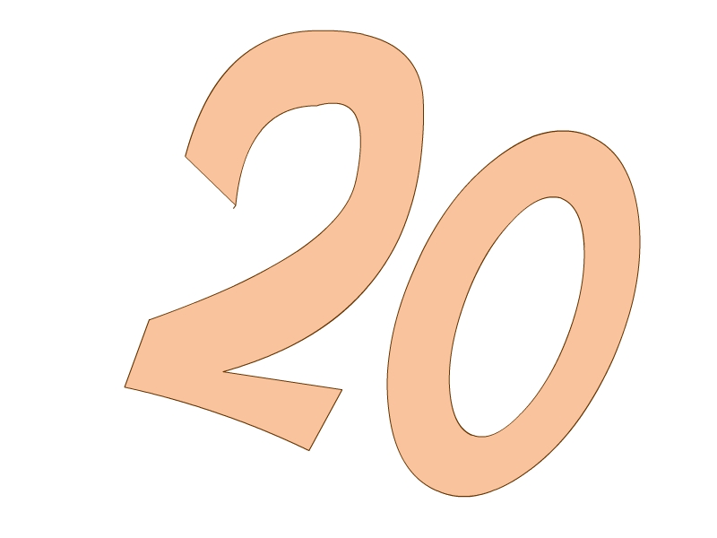 ( ) 2.
( ) 3.  ( ) 4. 
四、听录音，选择听到的句子。
( ) 1. A. I go to school at 8:00. B. I go home at 6:00.
( ) 2. A. Let’s fly the kite. B. Let’s ride a bike.
( ) 3. A. It’s 11:40. B. It’s 12:30.
( ) 4. A. It’s Monday. B. It’s Saturday.
( ) 5. A. What time is it? B. What day is it today?
五、听问句，选答句。
( ) 1. A. It’s Tuesday. B. It’s 12:30.
( ) 2. A. It’s 11:10. B. At 11:40.
( ) 3. A. It’s sunny. B. It’s Sunday.
( ) 4. A. It’s summer. B. I like swimming.
( ) 5. A. I go to school at 7:00. B. I go to bed at 9:00.
六、听录音，给图片排序。
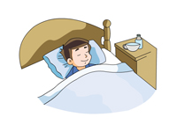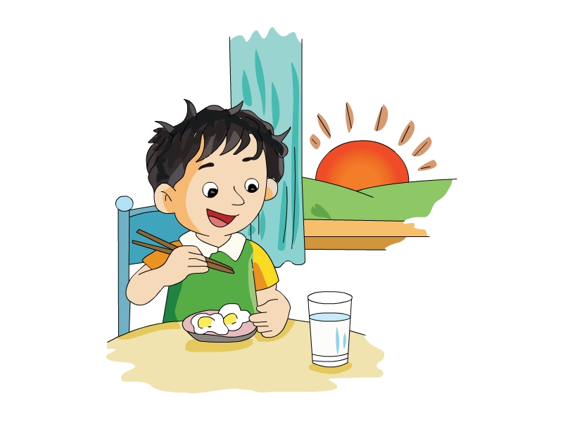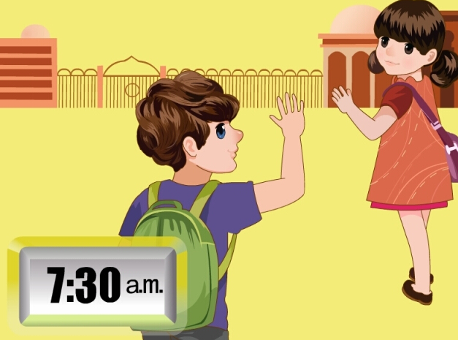
( ) ( ) ( ) ( )
笔试部分
一、写出字母的左右邻居。
1. ________ Qq ________ 2. ________ Uu ________
3. ________ Yy ________ 4. ________ Gg ________
5. ________ Dd ________ 6. ________ Ii ________
二、选择最佳答案。
( ) 1. —What day is it today?
—It’s ________.
A. sunny B. summer C. Sunday
( ) 2. —________ do you get up?
—At 7:00.
A. What B. When C. Where
( ) 3. —________?
—It’s 11:20.
A. What day is it?
B. What time is it?
C. What’s the weather like?
( ) 4. —What’s your favorite season?
—________.
A. Autumn B. Rainy C. Friday
( ) 5. —Can you make a snowman?
—No, ________.
A. I can B. I can’t C. you can't
三、读句子，选择正确的图片。
( ) 1. I can ride a bike.
A. 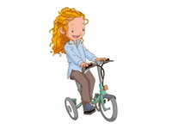 B. 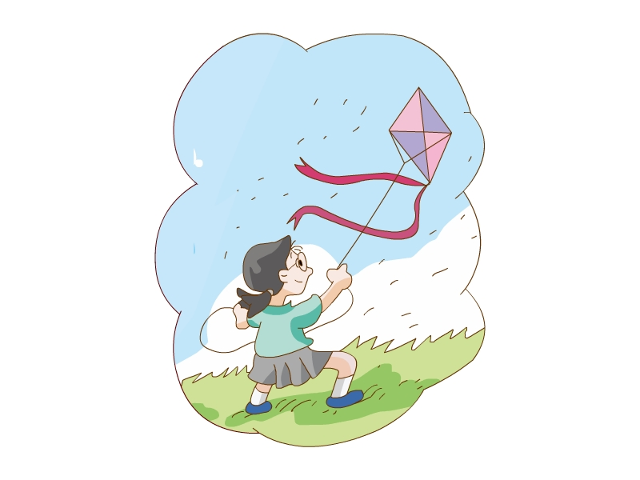
( ) 2. It’s snowy today.
A. 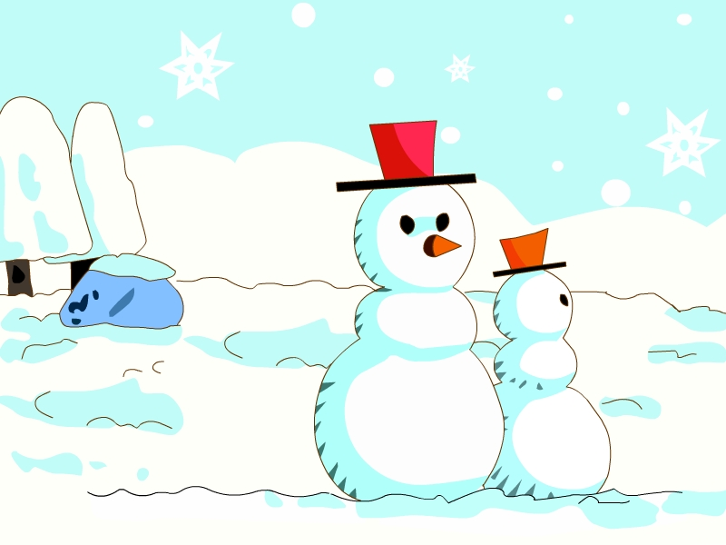 B. 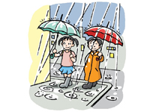
( ) 3. It’s eight thirty.
A. B.
( ) 4. It’s spring.
A.  B. 
( ) 5. I go home at five thirty.
A. B.

参考答案
听力部分
听力材料
—、
1. It’s twelve twenty.
2. eat dinner
3. It’s three forty.
4. Today is Tuesday.
5. I get up at 7:00.
6. It’s Sunday.
二、
A: (l) Mm (2) Ww (3) Ss (4) Xx (5) Yy
B: (1) Monday (2) thirty (3) fifty (4) today (5) Sunday
三、
1. twelve 2. It’s two ten. 3. It’s cloudy. 4. forty
四、
1. I go home at 6:00.
2. Let’s fly the kite.
3. It’s 11:40.
4. It’s Saturday.
5. What day is it today?
五、
1. What day is it today?
2. When do you eat lunch?
3. What’s the weather like?
4. What’s your favorite season?
5. When do you go to bed?
六、
1. I get up 2. go to school 3. eat breakfast 4. go to bed
听力答案
一、
1-6 ABBAAB
二、
A: (1)-(5) 25143
B: (1)-(5) 21354
三、
1-4 ×√√×
四、
1-5 BAABB
五、
1-5 ABAAB
六、
l 4 3 2
笔试部分
一、
1. Pp Rr 2. Tt Vv 3. Xx Zz 4. Ff Hh 5. Cc Ee 6. Hh Jj
二、
1-5 CBBAB
三、
1-5 AABBB

