双流某重点小学二年级下学期英语期末试题
听力部分
一、听录音，判断下列字母与录音是否一致，用“√”或“×”表示。
( ) 1. Jj ( ) 2. Hh
( ) 3. Ww ( ) 4. Dd
( ) 5. Ss
二、听录音，选择正确的图片。
( ) 1. A. 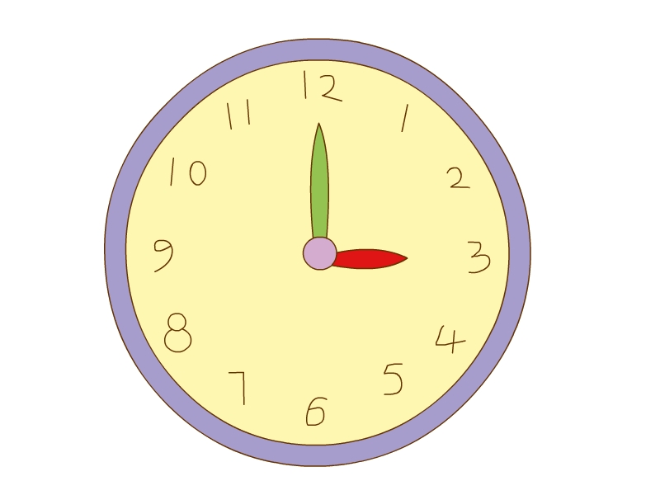 B. 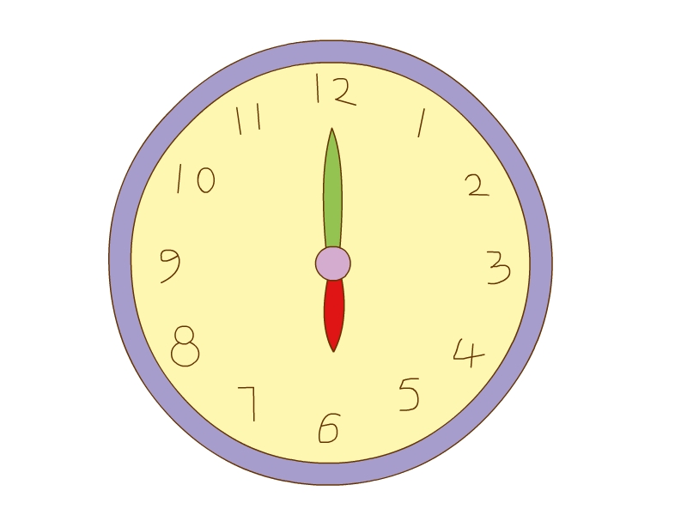
( ) 2. A. 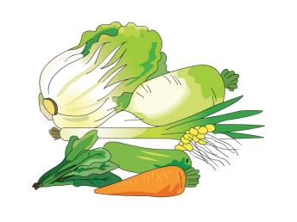 B. 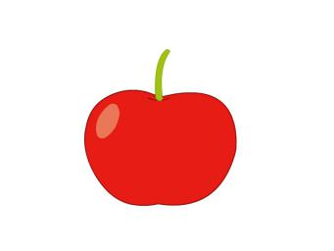
( ) 3. A. 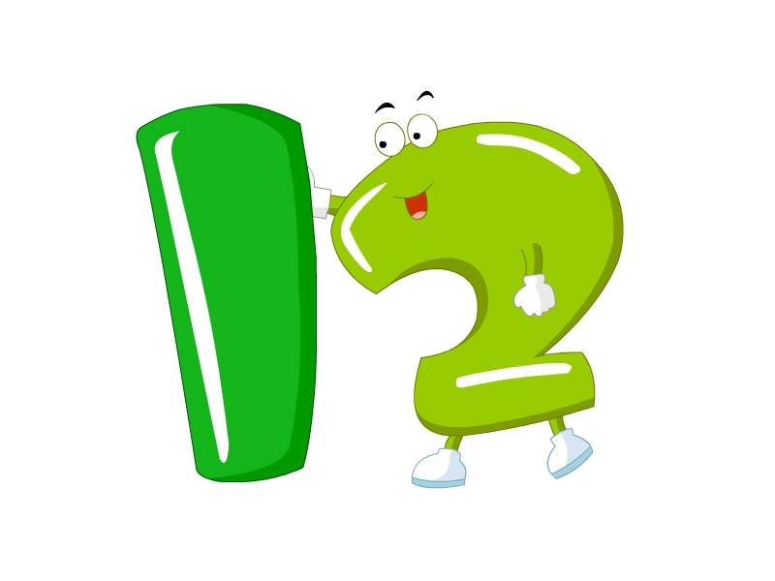 B. 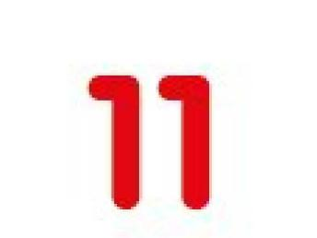
( ) 4. A. B.
( ) 5. A.  B. 
三、听录音，选择正确的单词补全句子。
( ) 1. My ________ season is autumn.
A. weather B. favorite C. time
( ) 2. It’s ________ in winter.
A. cool B. cold C. cloudy
( ) 3. It’s three ________.
A. fifty B. forty C. twenty
( ) 4. It’s ________ today.
A. Wednesday B. Thursday C. Friday
( ) 5. —________ do you eat dinner?
—At 6:00.
A. What B. What’s C. When
四、听录音，连线。
(1) 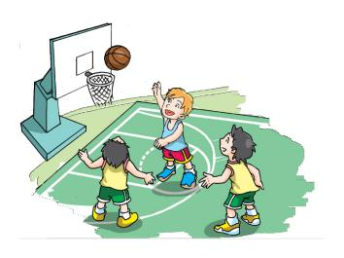 A.
(2) 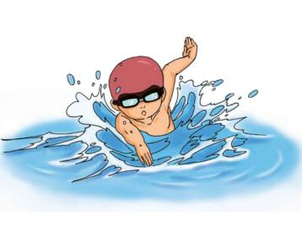 B. 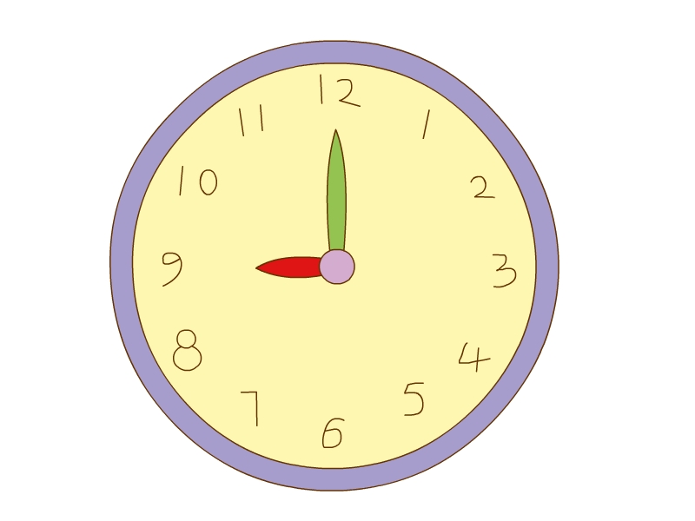
(3) C.
(4) 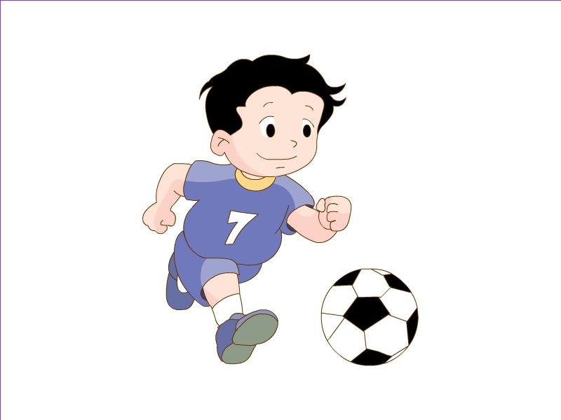 D.
五、听录音，判断图片正误，用“√”或“×”表示。
( ) 1. 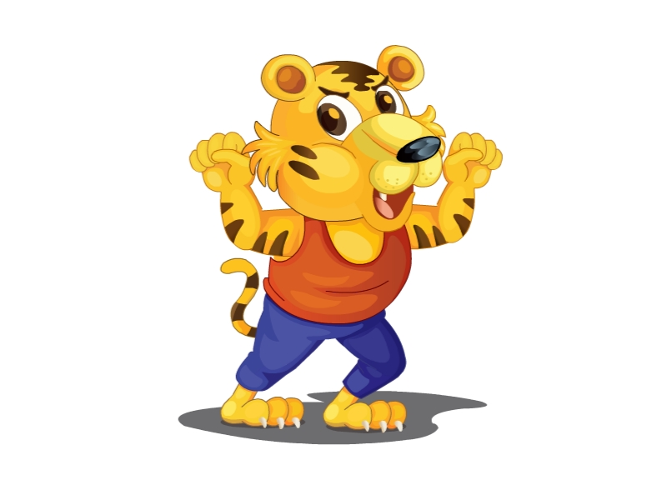 ( ) 2. 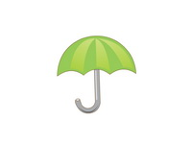
( ) 3.  ( ) 4. 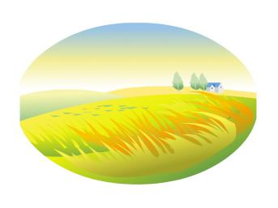
( ) 5. 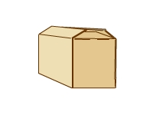 ( ) 6. 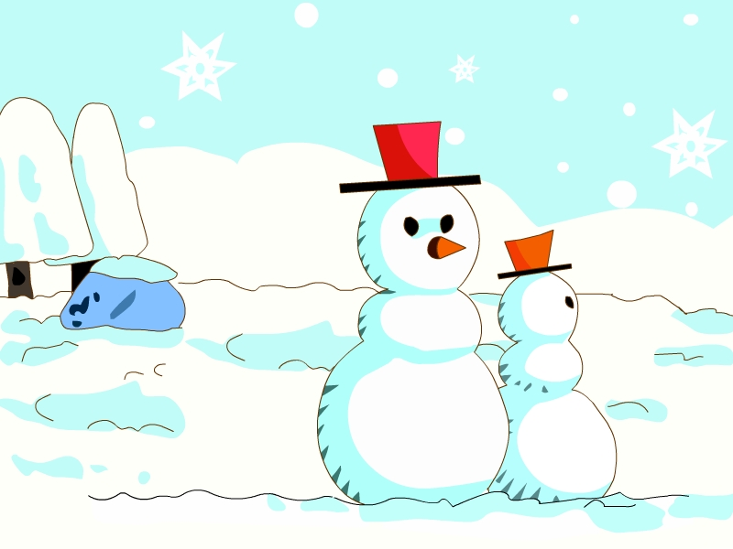
六、听录音，选择听到的句子。
( ) 1. A. When do you eat breakfast every day?
B. When do you eat dinner every day?
( ) 2. A. Can you make a model plane?
B. Can you make a snowman?
( ) 3. A. It’s cool and windy.
B. It’s warm and sunny.
( ) 4. A. I go home at 5:40.
B. I go to school at 7:40.
( ) 5. A. Today is Thursday.
B. It’s Tuesday today.
笔试部分
一、读一读，连一连。
A:
(1) 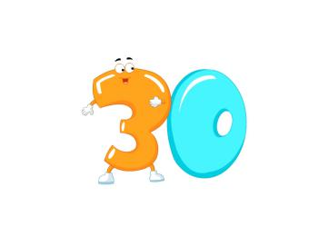 a. twelve
(2) 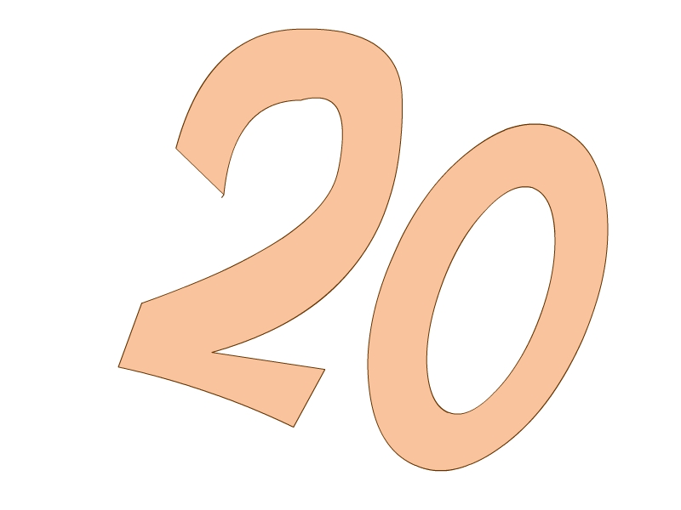 b. thirty
(3) 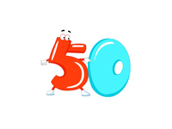 c. twenty
(4) d. fifty
B.
(1) 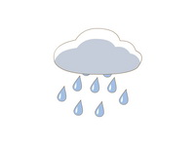 a. sunny
(2) 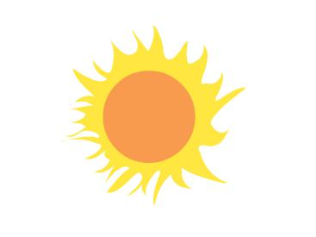 b. rainy
(3)  c. windy
(4)  d. cloudy
二、读一读，连词成句。
1. it, is, time, What, (?)
____________________________________________________________________
2. to, school, Let’s, go, (!)
____________________________________________________________________
3. fly, kite, a, I, can, (.)
____________________________________________________________________
4. is, It, Sunday, (.)
____________________________________________________________________

参考答案
听力部分
听力材料
一、
1. Gg 2. Hh 3. Mm 4. Bb 5. Ss
二、
1. It’s six. 2. vegetable 3. eleven 4. It’s twelve ten. 5. eat breakfast
三、
1. My favorite season is autumn.
2. It’s cold in winter.
3. It’s three twenty now.
4. It’s Wednesday today.
5. When do you eat dinner?
四、
(1) I play basketball at 9:00.
(2) I swim at 3:00.
(3) I go home at 5:40.
(4) I play football at 4:30.
五、
1. I can see a cat.
2. It’s an umbrella.
3. It’s water.
4. It’s autumn.
5. It’s a book.
6. I can make a snowman.
六、
1. When do you eat dinner every day?
2. Can you make a model plane?
3. It’s warm and sunny.
4. I go home at 5:40.
5. It’s Tuesday today.
听力答案
一、
1-5 ×√××√
二、
1-5 BABAA
三、
1-5 BBCAC
四、
(1)-(4) BADC
五、
1-6 ×√×√×√
六、
1-5 BABAB
笔试部分
一、
A: (1)-(4) bcda
B: (1)-(4) badc
二、
1. What time is it?
2. Let’s go to school!
3. I can fly a kite.
4. It is Sunday.

